**Name of the experiment:** Write a program BER analysis of a sample transceiver system. The transceiver is composed of a QPSK modulator, an Additive White Gaussian Noise(AWGN) channel, and a QPSK demodulator.

**Theory:** Quadrature Phase Shift Keying is a digital modulation method. In this method, the phase of the carrier waveform is changed according to the digital baseband signal. The phase of the carrier remains the same when the input logic is the 1 but goes a phase shift when the logic is 0. In Quadrature Phase Shift Keying, two information bits are modulated at once, unlike Binary Phase Shift Keying where only one bit is passed per symbol. Here, there are four carrier phase offsets with a phase difference of ±90° for four possible combinations of two bits( 00, 01, 10, 11). Symbol duration in this modulation is twice the bit duration.

**AWGN Channel**

Channel is the most important issue for any kind of communication system. Communication channel performance depends on noise. Additive white Gaussian Noise comes from many natural sources such as vibration of atoms in conductor, shot noise, radiation from earth and other warm object and from celestial sources such as the Sun. There are various kinds of communication channel. AWGN channel is the simplest model of a channel and is well suited for wired communication. This channel is linear and time-invariant (LTI). AWGN channel adds white Gaussian noise to the signal when signal passes through it. This channel’s amplitude frequency response is flat and phase response is linear for all frequencies .The modulated signals pass through it without any amplitude loss and phase distortion. So in such case, fading does not exist but the only distortion that exists is introduced by the AWGN. The received signal is simplified to

𝑟(𝑡)=𝑥(𝑡)+𝑛(𝑡)……..(1)

Where, n (t) represents the noise, has Gaussian distribution with 0 mean and variance as the Noise power and 𝑥(𝑡) represent transmitted signal.

**Bit Error Rate**

In a digital transmission, BER is the number of bits with errors divided by the total number of bits that have been transmitted, received or processed over a given time period.

$$That is BER=\frac{Number of bits with error}{total number of bits sent}$$

Bit error rate is a key parameter that is used in assessing the systems performance that transmits digital data from one location to another. When data is transmitted over a data link, there is a possibility of errors being introduced into the system . As a result, it is necessary to assess the performance of the system, and BER provides an ideal way in which this can be achieved. BER assesses performance of a system including the transmitter, receiver and the medium between the two.

**The constellation diagram of QPSK:**

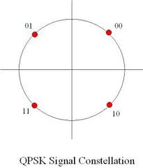

Each adjacent symbol only differs by one bit, sometimes known as quaternary or quadruphite PSK or 4-PSK. QPSK uses four points on the constellation diagram, equipped around a circle. With four phases, QPSK can encode two bits per symbol shown in the diagram to minimize the BER- twice the rate of BPSK. Analysis shows that this may be used either to double the data rate compared to a BPSK system while maintaining the bandwidth of the signal or to maintain the data rate of BPSK but half the bandwidth needed. The implementation of QPSK is more general than that of BPSK and also indicates the implementation of higher order PSK.  Writing the symbols in the constellation diagram in terms of sine and cosine waves used to transmit them. This yields the four phases π/4, 3π/4, 5π/4 and 7π/4 as needed. This results in a two dimensional signal space with unit basis functions. The first basis function is used as the in-phase component of the signal and the second as the quadrature component of the signal. Hence the signal constellation consists of the signal- space 4 points.

QPSK Modulator

The QPSK Modulator uses a bit-splitter, two multipliers with local oscillator, a 2-bit serial to parallel converter, and a summer circuit. Following is the block diagram for the same.

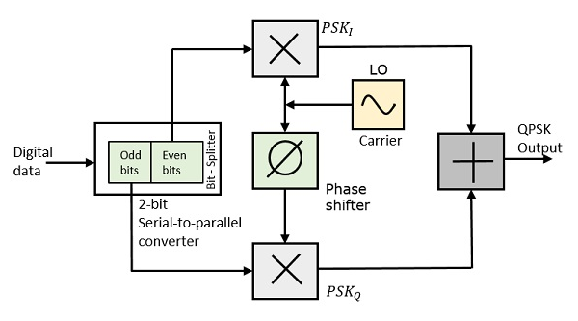

At the modulator’s input, the message signal’s even bits (i.e., 2nd bit, 4th bit, 6th bit, etc.) and odd bits (i.e., 1st bit, 3rd bit, 5th bit, etc.) are separated by the bits splitter and are multiplied with the same carrier to generate odd BPSK (called as PSKI) and even BPSK (called as PSKQ). The PSKQ signal is anyhow phase shifted by 90° before being modulated.

The QPSK waveform for two-bits input is as follows, which shows the modulated result for different instances of binary inputs.

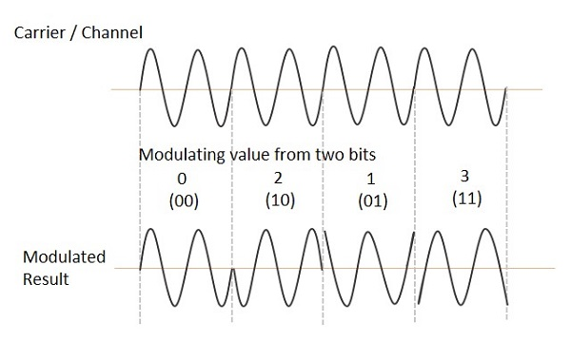

## QPSK Demodulator

The QPSK Demodulator uses two product demodulator circuits with local oscillator, two band pass filters, two integrator circuits, and a 2-bit parallel to serial converter. Following is the diagram for the same.

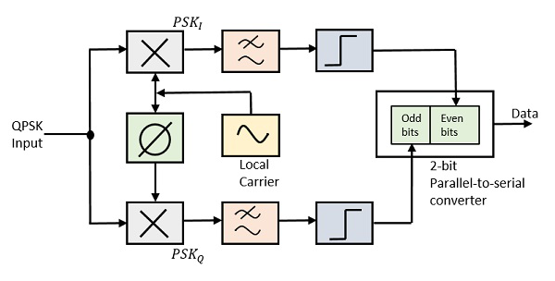

The two product detectors at the input of demodulator simultaneously demodulate the two BPSK signals. The pair of bits are recovered here from the original data. These signals after processing, are passed to the parallel to serial converter.

At the receiver end for demodulation, two product detectors are used. This product detectors convert the modulated QPSK signal into Even QPSK and Odd QPSK signals. Then the signals are passed through two [bandpass filters](https://www.elprocus.com/what-is-a-band-pass-filter-circuit-diagram-types-and-applications/) and two integrators. After processing the signals are applied to the 2-bit[parallel- to-series converter](https://www.elprocus.com/encoders-and-decoders/), whose output is the reconstructed signal.

**Bit Error Rate of QPSK:**

Simulating a QPSK system is equivalent to simulating two BPSK systems in parallel. So there is no difference in bit error rate(BER). Since the simulation is at baseband we multiply the in-phase and quadrature streams by 1 and j respectively (instead of cos and sin carriers). At the receiver we just use the real and imag functions to separate the two symbol streams. The BER is the average BER of the two parallel streams.

Assume,

$√p$

Average Power = p

1. - $\sqrt{p}$

Received Symbol ≥ 0 0

Received Symbol ≤ 0 1

X Y

n

y = x + n ---------- 1

x = 1 = - $\sqrt{p}$

Bit Error occurs, y ≥ 0

- + n ≥ 0 => n ≥ $\sqrt{p}$

Now, The probability density function, = Pe  = (n ≥ $\sqrt{p}$).

Now,

= $\int_{\sqrt{p}}^{∞}{ p\left(n\right) dn}={\left[\int_{\sqrt{p}}^{∞ }{{ \frac{1}{√2πσ^2} e}^{-n^{2}/2σ^2} dn}\right]}^{}$

= ${\left[\int_{\sqrt{\frac{p}{σ}}}^{∞ }{{ \frac{1}{\sqrt{2πσ}} e}^{-\frac{t^{2}}{2}} . σ dt}\right]}^{}$ Let, $\frac{n}{σ}=t$ => dn = $σdt$

= ${\left[\int_{\sqrt{p/σ}}^{∞ }{{ \frac{1}{√2π} e}^{-t^{2}/2} dt}\right]}^{}$

Now, the QPSK bit error = 2erfc $√\frac{2Eb}{N0}$

**Output:**

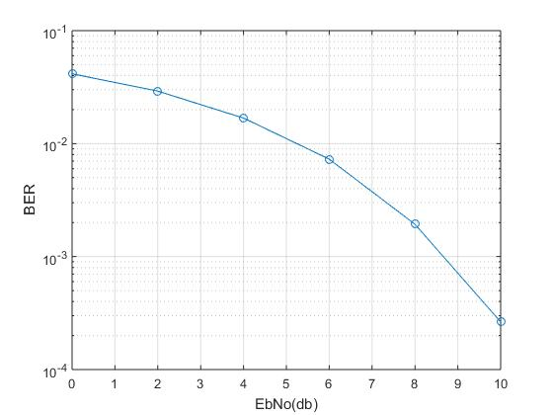

**Result Discussion:**

Our investigation involved simulating a QPSK modulation scheme with varying signal-to-noise ratios (SNR) and observing the resulting BER. The results indicated that as the SNR increased, the BER decreased. This is expected, as a higher SNR results in a stronger received signal, making it easier to detect and decode the transmitted data.

We also observed that the BER for the QPSK modulation scheme was lower compared to the BER of a BPSK modulation scheme under the same conditions. This is because QPSK modulation allows for the transmission of two bits per symbol, while BPSK can transmit only one bit per symbol. This higher spectral efficiency of QPSK allows it to achieve better performance under low SNR conditions.

However, we also found that there is a tradeoff between the number of bits transmitted per symbol and the susceptibility to errors. As the number of bits per symbol increases, the receiver becomes more susceptible to errors, particularly when the SNR is low. Therefore, selecting the appropriate modulation scheme and signal constellation for a given application requires balancing spectral efficiency and susceptibility to errors.

In summary, our investigation demonstrated that the BER of a QPSK modulation scheme with AWGN depends on the SNR and the modulation scheme's spectral efficiency. QPSK modulation with higher spectral efficiency achieved better performance than BPSK under the same conditions. However, a tradeoff exists between spectral efficiency and susceptibility to errors, and careful consideration is required in selecting an appropriate modulation scheme for a specific application.